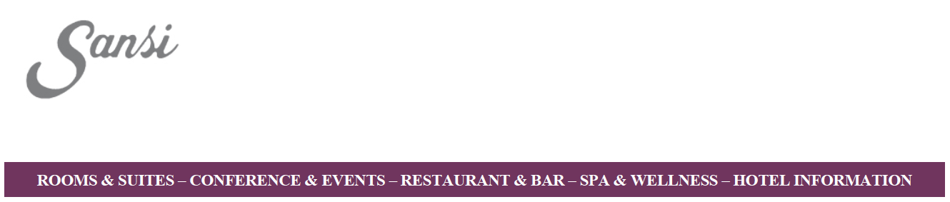

Dear Guest,

thank you for choosing Sansi Pedralbes Hotel for your next stay in the city.
It is a pleasure to confirm you have already completed the first step for validating your reservation in our hotel for the BPM 2017 – UPC congress.

To accomplish your reservation request we need you to fill this form in order to confirm and validate the information necessary to process your booking in our hotel.

Guest name and surname:

Arrival date:

Departure date:

Contact e-mail:

Credit card number and expiration:

Type room:
- Single/Double room for single use with breakfast: 156 euros+10% VAT
- Deluxe/Junior Suite with breakfast: 190 euros+10%VAT

Any special requests: (We provide our guests with a completely smoke-free envirorment.)

Cancellation Policy.
Reservations cancelled thirty (30) days or more before the date of arrival will incur no charges.
Reservations cancelled less than fifteen (15) days prior to the date of arrival will incur the charge of 100% of one night.
There are no refunds for “no shows”.

Please, do not hesitate to contact us for any details or questions you may have.

